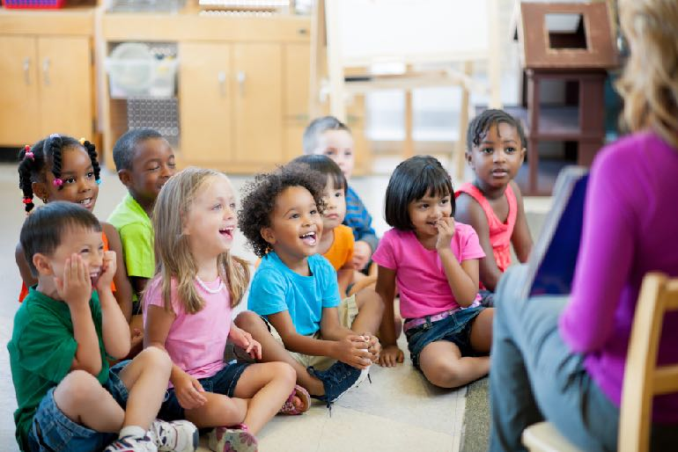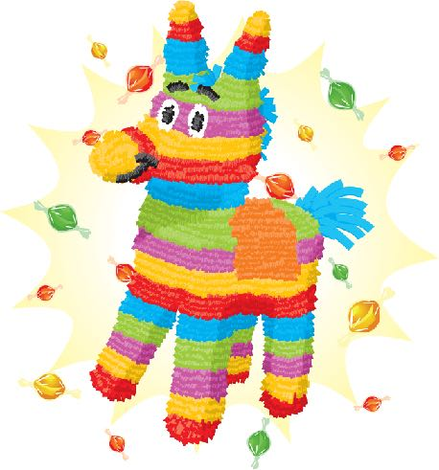

SPANISH

Dear Parents:

We are now offering Spanish at our center! All toddlers and preschoolers will learn Spanish every week taught by our very own team of teachers. Spanish class includes songs, games, puppets, culture, exercise, role-play, dance and much more! Parents, we give you the tools to practice Spanish as a family with our Monthly, Interactive Spanish Newsletters. You can look forward to your child speaking words and phrases in their second language! (The cost for Spanish is included in your tuition :-)

¡ESPAÑOL!