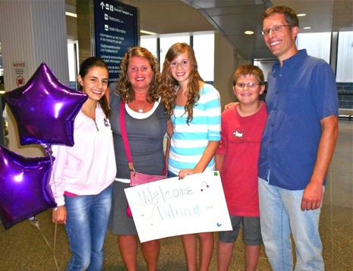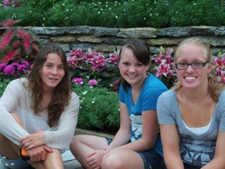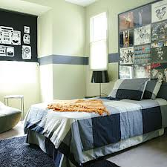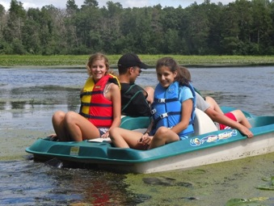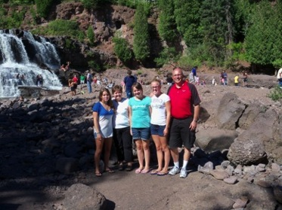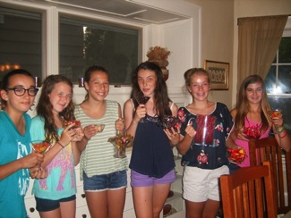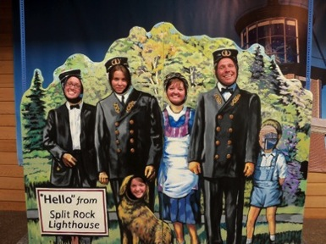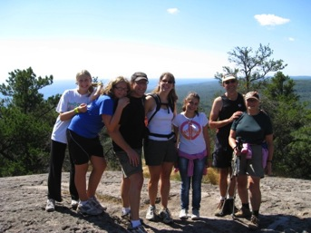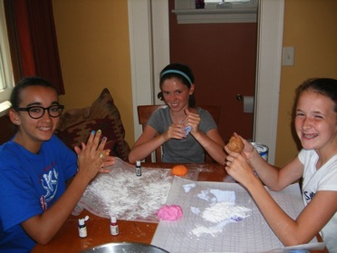 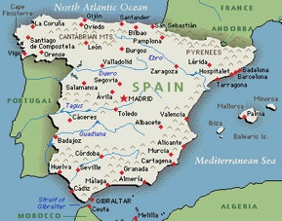  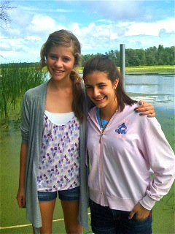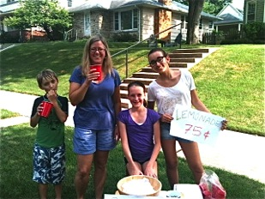

***The Krawczyk family welcomes Patricia from Toledo, Spain!***

ONEILL LANGUAGE ACADEMY: SUMMER 2016

|  |  |
| --- | --- |
| Tips to ensure the stay is rewarding | Pages  2-4 |
| Getting to Know Your Student | **Pages**  **5-6** |
| Excursion Ideas | **Page 2** |
| Get to Know Spain | **Pages**  **7-8** |
| Spain: The Basics | **Page 7** |
| Fun Facts about Spain | **Page 8** |
| Advice from a Previous Host Family | **Page 9** |
| For More Information | **Page 10** |

**TABLE OF CONTENTS**

* **tips for hosting an exchange student**

**Thank you for your interest in changing the lives of international exchange students and making a difference in your community!**

## Aenean a magna vel pede vestibulum rhoncus. Nulla cursus orci quis tortor.

To avoid isolation and culture shock, try taking your student on some exciting excursions, such as...

* Downtown Minneapolis
* Uptown Minneapolis Skyways of Minneapolis
* St. Paul
* Grand Avenue
* Seven Corners
* Downtown Stillwater
* The State Capitol
* The Landmark Center
* Fort Snelling
* The Science Museum
* The MN. History Center
* Canoeing/Fishing
* Biking
* Golfing
* Camping/Campfire
* BBQ
* Baseball Games
* The Minnesota Zoo
* Como Park Zoo
* Valley Fair
* Mall of America
* Sea Life Aquarium
* Nickelodeon Universe
* Water Park of America
* Local Farmer’s Markets
* Mill City Museum
* Midtown Global Market

*Sandra hangs out with her host sister and her new friend!*

**Tips to Ensure Your Host Student’s Stay is Rewarding for All!**

***Bedroom/Bathroom and Space****:* Think ahead about  where your exchange student  will sleep. If it is possible for  them to have their own bedroom that would be ideal but  it is not always possible. It is  fine for them to share a bedroom with one of your children of the same gender and of  a similar age. If your ex change student will share a  room, make sure they will have  drawers in a dresser and closet space to store their clothes and belongings. If possible give them a desk or table where they can sit and write a letter to their family or work on their computer if they bring one. By giving your exchange student their own space they can relax when they need some down time and your family will also have some time to yourselves.

Your student is expected to make their bed everyday and to keep their room and space neat and tidy. Of course make sure their bed sheets are clean and change them once a week. Be sure to give them clean towels and show them where your store the towels and toilet paper etc. Show them where they can store their toiletries and which bathroom they can use to shower and brush their teeth, etc. Also, show them how the shower works, etc.

*Page 2 Tips for Hosting An Exchange Student*

*Patricia goes paddle boating with her host sister, Maggie!*

*Don’t forget to take lots of photos to share with friends and family and your host student’s family!*

***Extra Special:*** It would be a wonderful touch to prepare a care package for your exchange student and have it waiting in their bedroom for when they arrive. Some ideas include: a magazine based on their interests and age-level (for example Sports Illustrated, People, Arts and Crafts, etc.), a book about Minnesota, a word search or crossword puzzle ($ Store), or a calendar with pictures of Minnesota. Another idea is to have some candy bars, gum, fresh fruit like apples or simple snacks that they could have in case they get hungry after hours and would like to snack on something but are nervous to go to your kitchen when everyone is in bed. Be sure they take a bottle of water or a glass of water to bed with them! (Just think about what your child might like in a care package if (when) they go to Spain for a visit and plan accordingly.)

***Getting to know the exchange family BEFORE the stay:*** It is a great idea to Skype, email and facebook your exchange family. Getting to know them this way first is a wonderful way to put everyone at ease and break the ice before meeting at the airport! This will let them know that you are excited to have their child as part of your family this summer! Also, email them some pictures of your family, perhaps the outside of your house, your block and even a snap shot of their bedroom. Just think how relieved you would be as a parent if you had pictures of the people your young child would be staying with and where they will be staying!

***Email them an itinerary of what you may be doing together:***

It can change but it will give them a lot to look forward to and it will help you plan your time with them in advance. Let them know what kind of clothes to pack, what the temperature will be, etc. If you plan to take them to a formal event such as a wedding, be sure to tell them to pack a tie or a dress. If they will go swimming, tell them to bring a swimsuit. Give them an idea of how many pairs of shorts and pants to bring and what kind of shoes, etc. Tell them if you will provide a beach towel, shampoo, a blow dryer, curling iron, toothpaste, so if you will provide these things, they don’t need to pack them.

*O’Neill Language Academy, Inc. Page 3*

*Sandra goes hiking with her host family!*

***At the Airport:*** It would be wonderful to make a poster welcoming with balloons at the airport. When I told one Spanish mom that sometimes we welcome children with a poster and balloons she said, “That would be just like we have seen in the movies!” I think she REALLY liked that idea and thought of her son being welcomed into a new country and family with balloons and a special poster. If your entire family can go to meet them that would make them feel extra special! Remember that they will have jet lag so for the first couple of days they may seem a bit tired and out of sorts. Spain is seven hours ahead of Minnesota. IF YOU HAVE A PHONE WITH A CAMERA, TAKE A PICTURE OF THEIR ARRIVAL-WITH BALLOONS AND POSTER AND EMAIL IT IMMEDIATELY TO THEIR FAMILY IN SPAIN SO THEY KNOW THEY ARRIVED SAFELY!!!

***Getting to know your family, neighbors, friends:*** By the first weekend it would be awesome to invite your close friends, neighbors and family members over for a welcome party. Beforehand show your student pictures of who will be coming and go over their names and how they are related so when your student meets them it will not be so overwhelming.

Then, at the welcome party take pictures of all the members together with your exchange student. You can give one copy to your student, send one to his family in Spain and put one on the wall at your home. Label all the members with their names and relationship. This will help your student learn the names of your family and friends!

Talk to your family members (who do not live with you) as well as friends and neighbors  to see if they want to have your student over for an afternoon or take them somewhere special like the zoo, bowling, a movie, or the State Capitol. This will give your family a little break and give your student a chance to meet new people!

*Page 4 Tips for Hosting An Exchange Student*

***Get to know your host student:*** Your student will feel more comfortable with you and you with them if you get to know them by asking questions about them. Ask about their parents, family, their home, their country and city. Also ask about their friends, their hobbies, their childhood, their ambitions and so much more. Show interest in them and where they are from and about their culture, etc.

***Include your host student in everything you do:***

Watch movies together, play cards together, listen to music together, invite them to take part in all of your family activities so they really start to feel like a member of your family. This will make the experience of living together much more enjoyable.

***Explain your family’s schedule:*** What time is dinner? What can he or she eat for breakfast? Should they make any meals for themselves or is someone in charge of making them? What time does everyone go to work and get home? Will they be alone for part of the day? If so, are there some things they can do such as take a walk, use your computer, etc.

***Other things you will want to let your exchange student to know:***

If you have pets tell them any rules or routines associated with your pet(s). What time does your family go to bed? What rules do you have for your children that will extend to your exchange student?

***Ask lots of questions to insure your exchange student is happy:***

You may  want to ask these questions to make sure your student is comfortable and happy. What types of  food do you like? Do you have enough blankets?  Do you need to wash any clothes? Is the house  too cold or hot for you? Can I get you anything  special at the grocery store? Are you getting enough to eat? Are you okay with the dogs/cats? Are there any special places you would like to go? Shopping, for example for gifts for your family in Spain?

GETTING TO KNOW YOUR STUDENT

*TIPS TO ENSURE YOUR STUDENT IS COMFORTABLE AND HAPPY*

*O’Neill Language Academy, Inc. Page 5*

***Helping Your Exchange Student with English:***

Ask your student if you may correct them in English. They will most likely be eager to have your help! If you hear your student make the same mistakes over and over, gently correct them as this is the best way for them to learn the language while immersed in it. You can correct their pronunciation, vocabulary usage, grammar, etc. Do not over-do it by interrupting them at each mistake, but occasional corrections are good.

***Encouragement:***

Throughout his/her home stay, your student may feel homesick or culture shock in the form of disappointment in his achievement in English. Therefore it is important to encourage them for accomplishing small achievements. Some small achievements may be answering the telephone, talking to a relative or family member or friend by himself or herself and/or at length. Speaking correctly, correcting their own mistakes, helping around the house, etc. The more praise you give, the more quickly they will adapt.

***Culture Shock:***

In my opinion the most difficult part of his/her stay is that your student will feel a bit isolated which is a form of culture shock. Most Spaniards live and work and hang out near lots of people and action. They live near or above shops and bars and restaurants, they take walks to the town plaza or meet friends at a public spot, they like to surround themselves with people, conversation and movement of the bustling city. One way to help them ease into our culture of independency, where privacy is the key to our quality of life, is to take him/her on outings. Check out our suggested excursion list on page 2 for some ideas!

*Page 6 Tips for Hosting An Exchange Student*

*Plaza Mayor in Madrid, Spain*

***Spanish Family Values:*** Families are very close in Spain. They spend a great deal of time together and enjoy being in the same room together. They engage in conversations and tend to speak louder and stand closer to each other when talking than Americans. They use more hand gestures when talking and are generally more expressive. Children accompany parents to bars, restaurants, everywhere, even young children. The family unit is very close. Noise is the key to any good family meal in Spain. Silence is rare at the Spanish table! Sometimes they even leave the television on and talk over it!

***Table Manners:*** In Spain it is polite to have your hands and/or elbows on the table. It is not polite to put your hands in your lap at the table. It is also okay, especially with one’s family, to reach for food instead of asking it be passed. Americans tend to use more niceties such as “please,” “thank you” and “you’re welcome” than Spaniards. This does not mean that they are not grateful; it is just not as prevalent in Spain to use these words as often as Americans.

***Dress***: Spaniards tend to dress more formal than Americans. Shorts are usually only worn when exercising or playing sports, even on the hottest days. The same is true of tennis shoes and t-shirts. Baseball caps are not typical for Spaniards. Blue jeans, a shirt with a collar and loafers are common for a Spanish male.

***Population***: 47,190,493

***Religions***: Roman Catholic 94%, Other 6%

***Government***: Parliamentary Monarchy Languages:

The official language is Spanish, also called Castilian, and is the first language of over 72% of the population.

Galician is spoken in the region of Galicia and Basque by increasing numbers of the population of Euskadi, the Spanish Basque Country.

Catalan is spoken in Catalonia and the Baleric Is- lands and the closely related Valencian in the Valencia region.

**THE BASICS**

GET TO KNOW SPAIN

*O’Neill Language Academy, Inc. Page 7*

*Page 8 Tips for Hosting An Exchange Student*

FUN FACTS ABOUT SPAIN

* Spain is the only country that includes bull fighting as a sport
* Spain produces 44% of the world’s olive oil
* Spanish is the second most spoken language in the world
* Spain is the only country in Europe that produces bananas
* There is no tooth fairy in Spain but a mouse called, Ratoncito Perez
* Spain is derived from Ispania, which means land of rabbits

***Tapas***: A tradition began long ago in the southern city of Seville. Spaniards have since perfected the art of snacking. Going out for tapas consists of traveling from bar to bar and sharing plates of the bars’ appetizer specialties with small groups of friends.

***Sobremesas***: This is the art of conversation after a meal. Instead of taking the last bite and leaving, Spaniards often stay at the table conversing, savoring each other’s company and perhaps sharing a drink. If good conversation ensues, be prepared to stay for hours!

***The Spanish siesta:*** No, it is not a myth. Yes, the infamous siesta really does exist.It began long ago as after eating the large mid- day meal farm workers needed to rest and digest before going back tout to work in the fields. While this daily break doesn’t necessarily include e a nap, businesses and stores do shut down for about two hours and many people return home to each with their families.

***Meals:*** A normal day’s breakfast typically consists merely of a cup of coffee and a croissant or pastry or a piece of toast with butter and jelly. They eat a very small breakfast.Spaniards eat their lunch between 2:00 and 4:00 pm. Lunch is their main and largest meal. A typical lunch will have several courses. The first is the lighter part of the mal, usually consisting of a salad or soup while the second course is normally your typical fish or meat dish. A dessert can be a small piece of fruit, flan or a piece of cake or sweet pastry. The dinner is usually much smaller than the lunch. It consists of something light like a salad, a sandwich or a selection of tapas. They

tend to each dinner between 9:00-11:00pm.

*Patricia with her host sister, Maggie*

Have things on and that will be familiar with like Nutella.

Be prepared to aid them in communication with family back home. We bought cheap Skype minutes so our student could call her mom’s mobile when she was homesick

Be prepared for your student to hit the wall after roughly one week. The initial excitement has worn off, they’ve adjusted to the time and the reality of not seeing their family and friends for another three weeks starts to sink in. Have activities planned to help keep them busy to avoid homesickness

Be prepared for the student to just need some down time and/or alone time. Don’t take this personally. It takes a lot of mental energy for them to focus and speak English all day every day. This was hard for our kids initially because we understood as parents that this was her time to rest but it was sometimes incorrectly interpreted as anti-social by our kids.

I think every kid will be different but our student was amazed by the sheer variety and volume of sweets available in our country. For Christmas we sent our student a variety box of candies and cookies, like Oreos that she liked, so she could share them with her friends and family.

*Angela helps her host family with a lemonade stand!*

ADVICE FROM A PREVIOUS HOST FAMILY

*O’Neill Language Academy, Inc. Page 9*

For More Information:

Theresa Gunderson

Director

O’Neill Language Academy

[www.oneilllanguage.com](http://www.oneilllanguage.com)

[director@oneilllanguage.com](mailto:director@oneilllanguage.com)

651-264-0404

O’Neill Language Academy is a small family business that is located in St. Paul, Minnesota. Jim and Theresa Gunderson founded OLA in 1991 to offer Spanish language classes and tutors for students, young and old. OLA now offers a total of nine languages in schools, homes and businesses!

Three years ago OLA started the Study Abroad program for Spanish exchange students between the ages of thirteen and eighteen to experience American culture while learning English and staying with a host family. We pride ourselves on matching each exchange student with a family that has a child of the same age and gender. We also try our best to match exchange students with American families that share the same interests to ensure an unforgettable experience for all involved!

We are here for you before your student arrives, during their stay and after they leave. If you have any questions or concerns at any time, please feel free to contact us!

*Page 10 Tips for Hosting An Exchange Student*

*Theresa and Jim Gunderson in Spain!*

***Thank you for making this wonderful opportunity become a reality for your family and your exchange student!***

WE ARE HERE TO HELP YOU!